The Wealth Attraction Power University (WAPU)
Introduction to the Home-Study Course
The 8 Principles of Tao-Nomiks'
The Right Know-Ledge of Health, Wealth & Spiritual Power
“Divide Your Portion to 7 or even 8 Ways, for You Know NOT
what DISASTER may come” Ecclesiastes 11:2
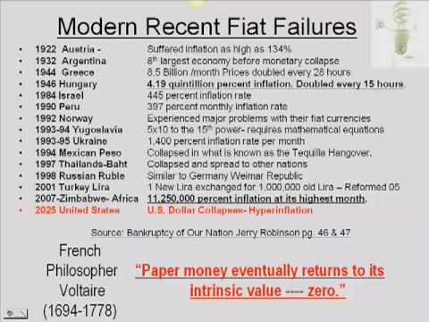
Following are the 8 Principles' of Tao-Nomiks'. By Following them
You are Guaranteed to Build Wealth.

Wealth Building Know-Ledge {WAP Mindset}
“My People are Destroyed for a LACK of Knowledge” -Hosea 4 :6

Many of you were given two great gifts: your mind and your time. It is up to you to do what you please with both. With each dollar bill that enters your hand, you and only you have the power to determine your destiny. Spend it foolishly, you choose to be poor. Spend it on liabilities, you join the middle class. Invest it in your mind and learn how to acquire assets and you will be choosing wealth as your goal and your future. The choice is yours and only yours. Every day with every dollar, you decide to be rich, poor or middle class. Choose to share this knowledge with your children, and you choose to prepare them for the world that awaits. No one else will. You and your children's future will be determined by choices you make today, not tomorrow.
"The main reason people struggle financially is because they spent years in school but learned nothing about money. The result is, people learn to work for money, but never learn to have money work for them."
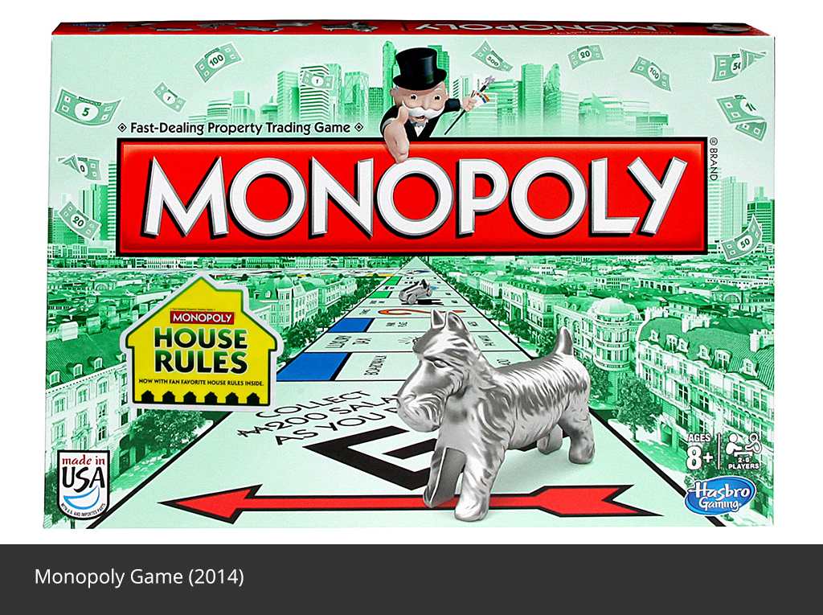
Learn the Game, then Play to Win !

“Man’s chief delusion is his conviction that there are causes other than
His own state of consciousness.”
—NEVILLE GODDARD, BARBADIAN AUTHOR AND MYSTIC

Wise Spending & Saving
“And S/He that gives to the RICH shall surly come to want” -Prov. 23:16

Personal or family budget
In a personal or family budget all sources of income (inﬂows) are identiﬁed and expenses (outﬂows) are planned with the intent of matching outﬂows to inﬂows (making ends meet). In consumer theory, the equation restricting an individual or household to spend no more than its total resources is often called the budget constraint. Elements of a personal or family budget usually include, ﬁxed expenses, monthly payments, insurance, entertainment, and savings.

Spend Now & Suffer Later, Save Now & Live Good Later

Cash Flow
“And GOD/DESS said to Them ; Be Fruitful & Multiply” -Gen. 1:28

There are only seven essential money skills that will take you to financial security. There are only seven things that wealthy people are good at and that take them with certainty toward financial success. You only need to do seven things well. We call these Money Skills, and they are:

Have Multiple Income Streams
1. Make it
2. Manage It
3. Save It
4. Invest It
5. Value It
6. Shield It
7. Share It

Perfect Credit -How to build credit from scratch
“Be NOT Thou one of THEM...that are a SURITY for DEBTS” -Prov. 22:29


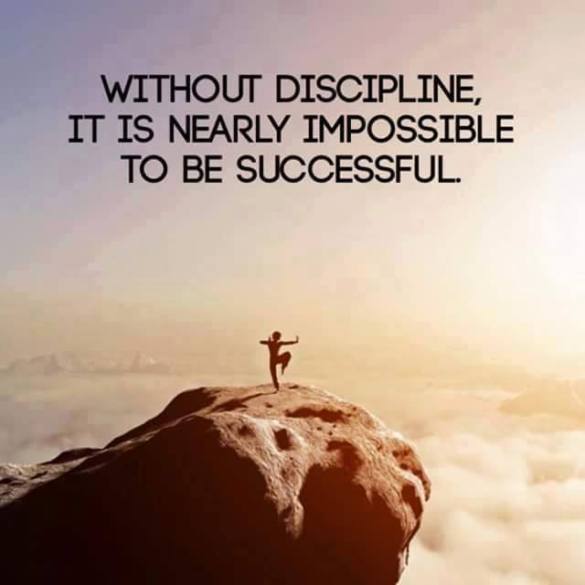
Credit can help Make You or it can Brake You
Whether you are just starting out or starting over, figuring out how to build credit can be confusing. Don't let it overwhelm you. There are some simple steps you can take right now to establish credit. Before you know it, lenders will be chasing you with offers.
O.P.M. -Other Peoples Money
“For the LORD will plead Their Cause” -Prov. 22:23

Loans
In ﬁnance, a loan is a debt provided by an entity (organization or individual) to another entity at an interest rate, and evidenced by a note which speciﬁes, among other things, the principal amount, interest rate, and date of repayment. A loan entails the reallocation of the subject asset(s) for a period of time, between the lender and the borrower. In a loan, the borrower initially receives or borrows an amount of money, called the principal, from the lender, and is obligated to pay back or repay an equal amount of money to the lender at a later time. The loan is generally provided at a cost, referred to as interest on the debt, which provides an incentive for the lender to engage in the loan.
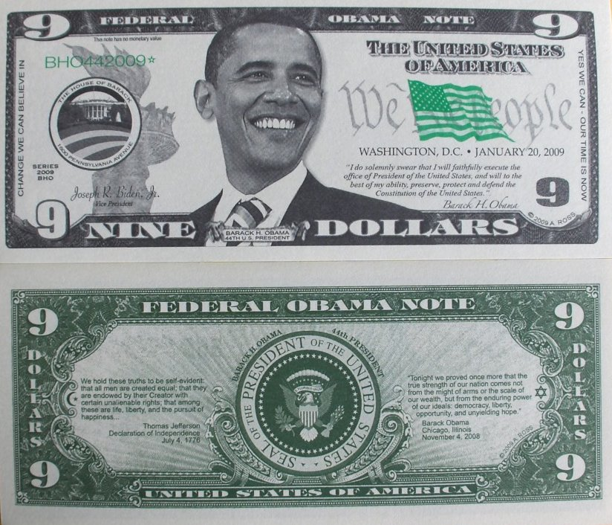
When You don't have the Money, Use other Peoples Money !

Asset Protection Strategies
“A Wise Person foresees EVIL & HIDES Themselves -Prov. 22:2

Asset Protection involves a variety of legal techniques (based on both statutory and common law) dealing with protecting assets of individuals and businesses from civil money judgments. “Asset protection” has developed a bad reputation in part due to questionable offshore planning techniques. Some offshore “tax haven” schemes have been marketed to investors who have ultimately ended up in deep trouble with the IRS and other federal agencies. Many asset protection strategies, however, are ethical and highly advisable. Basically, asset protection planning simply makes use of laws that were passed to enable organizations and individuals to protect their assets. An analogy can be drawn to tax planning. Some schemes that are called “tax planning” are nothing more than illegal and fraudulent evasions of taxes. Legitimate tax planning, however, is essential for both businesses and individuals. Similarly, legitimate asset protection planning is important for both businesses and individuals.



Protect Your Ass !

Estate Planning
“A Good Person leaves an Inheritance for Their Children's Children -Prov. 13:22

It’s important to have an estate plan. You want to make sure the assets you’ve worked so hard to accumulate during your lifetime go to the people or organizations you care about. Estate planning can be a complex process, but you can make it easier with the support of capable, experienced professionals, or Learning to DIY Do It Yourself !
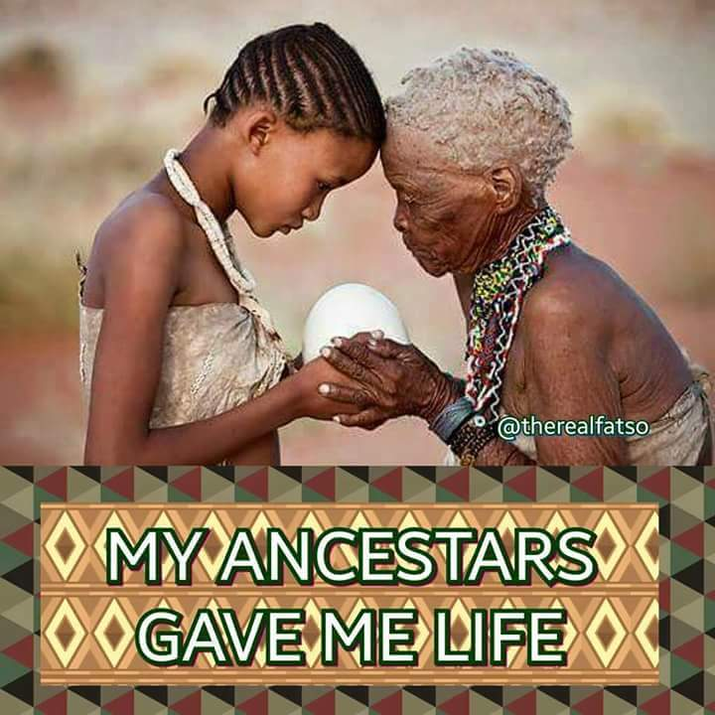
Build Wealth for the Future Generations

Asset Accumulation
“And the Wealth of the SINNER is laid up for the Just” -Prov 13:22

Collecting For Passion Or Investment or Both
Why do people collect ? Many have asked themselves, and there is no easy answer.
20th Century British art historian, author and broadcaster Kenneth Clark —the grand art historical explainer—thought it was analogous to asking why people fall in love: they are various and irrational. Yet collectors and inheritors (their overlooked counterparts) are driven by motives ranging from curiosity and passion to financial gain and tax relief. While many feel an emotional involvement with their collections some view them as disposable assets akin to stocks, bonds, and real estate.
Historically, collectors have pursued objects such as fine art, jewelry and gems, collectibles, antiques and other personal property with a dedication and discernment rivaling that of an artist in the throes of creation. Others have collected objects as a commodity to be arbitraged and flipped by committing capital to investment vehicles such as art funds or private equity funds. Their fund managers are expected to forecast that their portfolio of illiquid assets will have a greater value tomorrow than it does today.
Nevertheless, collectors establish their authenticity by possessing objects of desire. Similarly, artists attain their originality by the act of creation. Both choices are intimate expressions of the self. Thus, the sum of the objects— collected or created—exceeds the sum of the parts.

Collect what You Love, and it won't be “WORK”

COLLECTING
The WAPU Course will assist new and experienced collectors alike in building and managing a collection with confidence. It Teaches what to look for in an object, how to document objects, how to care for a collection, and how to initiate an estate planning program for a collection. These tasks are a prerequisite to devising a successful long term collecting strategy. Additionally, a good collector must understand the uncertain outcome of his or her collection just as an artist acknowledges the unknown result of his or her creation. The collector is on a voyage of discovery, often encountering the less attractive attributes of collecting (envy, frustration and despair) while also experiencing the desirable ones (joy, triumph and rarefied bliss). -Not to mention Wealth Building !

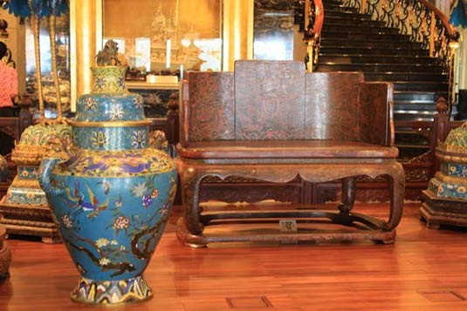
When Collecting Assets Your Home becomes Your
“Treasure Chest”


